此篇论文是关于迁移学习的综述，首先介绍了迁移学习的定义，然后介绍了近年来的关于Homogeneous transferlearning” and “Heterogeneous transfer learning 和“Negative transfer的方面的论文（只是提到了方法和来源，并没有提出新的观点或者进行深入的讨论）。

迁移学习可以从现有的数据中迁移知识，用来帮助将来的学习。迁移学习（Transfer Learning）的目标是将从一个环境中学到的知识用来帮助新环境中的学习任务。因此，迁移学习不会像传统机器学习那样作同分布假设。

conditional probability based multi-source domain adaptation (CP-MDA)：

方法来源：

Chattopadhyay R, Ye J, Panchanathan S, Fan W, Davidson I. Multi-source domain adaptation and its application to

early detection of fatigue. ACM Trans Knowl Dis Data (Best of SIGKDD 2011 TKDD Homepage archive) 2011; 6(4)

(Article 18).

two stage weighting framework for multi-source domain adaptation（2SW-MDA）：同时处理条件分布和边际分布

来源：

Duan L, Xu D, Tsang IW. Domain adaptation from multiple sources: a domain-dependent regularization approach.

IEEE Trans Neural Netw Learn Syst. 2012;23(3):504–18.

及

Chattopadhyay R, Ye J, Panchanathan S, Fan W, Davidson I. Multi-source domain adaptation and its application to

early detection of fatigue. ACM Trans Knowl Dis Data (Best of SIGKDD 2011 TKDD Homepage archive) 2011; 6(4)

(Article 18).

FAM（feature augmentation method）：

来源：

Daumé H III. Frustratingly easy domain adaptation. In: Proceedings of ACL. 2007. p. 256–63.

DTMKL（domain transfer multiple kernel learning）：

来源

Duan L, Tsang IW, Xu D. Domain transfer multiple kernel learning. IEEE Trans Pattern Anal Mach Intell.

2012;34(3):465–79.

JDA（joint domain adaptation）：

来源

Long M, Wang J, Ding G, Sun J, Yu PS. Transfer feature learning with joint distribution adaptation. In: Proceedings

of the 2013 IEEE international conference on computer vision. 2013. p. 2200–07.

ARTL（Adaptation Regularization based transfer learn-ing）:

来源

Long M, Wang J, Ding G, Pan SJ, Yu PS. Adaptation regularization: a general framework for transfer learning. IEEE

Trans Knowl Data Eng. 2014;26(5):1076–89.

TCA（transfer component analysis）：

来源

Pan SJ, Tsang IW, Kwok JT, Yang Q. Domain adaptation via transfer component analysis. IEEE Trans Neural Netw.

2009;22(2):199–210

SFA（spectral feature alignment）:

来源

Pan SJ, Ni X, Sun JT, Yang Q, Chen Z. Cross-domain sentiment classification via spectral feature alignment. In:

Proceedings of the 19th international conference on world wide web. 2010. p. 751–60.

SDA（stacked denoising autoencoder）:

来源

Glorot X, Bordes A, Bengio Y. Domain adaptation for large-scale sentiment classification: A deep learning

approach. In: Proceedings of the twenty-eight international conference on machine learning, vol. 27. 2011. p.

97–110.

GFK（geodesic flow kernel）:

来源

Gong B, Shi Y, Sha F, Grauman K. Geodesic flow kernel for unsupervised domain adaptation. In: Proceedings of the

2012 IEEE conference on computer vision and pattern recognition. 2012. p. 2066–73.

DCP（discriminative clustering process）:

来源

Shi Y, Sha F. Information-theoretical learning of discriminative clusters for unsupervised domain adaptation. In:

Proceedings of the 29th international conference on machine learning. 2012. p. 1–8.

TCNN（transfer convolutional neural network）:

来源

Oquab M, Bottou L, Laptev I, Sivic J. Learning and transferring mid-level image representations using convolu-

tional neural networks. In: Proceedings of the 2014 IEEE conference on computer vision and pattern recognition.

2013. p. 1717–24.

MMKT（multi-model knowledge transfer）:

来源

Tommasi T, Orabona F, Caputo B. Safety in numbers: learning categories from few examples with multi model

knowledge transfer. IEEE Conf Comput Vision Pattern Recog. 2010;2010:3081–8.

DSM（Domain Selection Machine）:

来源

Duan L, Xu D, Chang SF. Exploiting web images for event recognition in consumer videos: a multiple source

domain adaptation approach. In: IEEE 2012 conference on computer vision and pattern recognition. 2012. p.

1338–45.

MsTrAdaboost/ TaskTrAdaboost：

来源

Yao Y, Doretto G. Boosting for transfer learning with multiple sources. In: Proceedings of the IEEE computer society

conference on computer vision and pattern recognition. 2010. p. 1855–62.

RAP（Relational Adaptive bootstraPping）:

来源

Li F, Pan SJ, Jin O, Yang Q, Zhu X. Cross-domain co-extraction of sentiment and topic lexicons. In: Proceedings of

the 50th annual meeting of the association for computational linguistics long papers, vol. 1. 2012. p. 410–19.

SSFE（sample selection and feature ensemble）：

来源

Xia R, Zong C, Hu X, Cambria E. Feature ensemble plus sample selection: domain adaptation for sentiment clas-

sification. IEEE Intell Syst. 2013;28(3):10–8.

此论文中提到的方法如下：

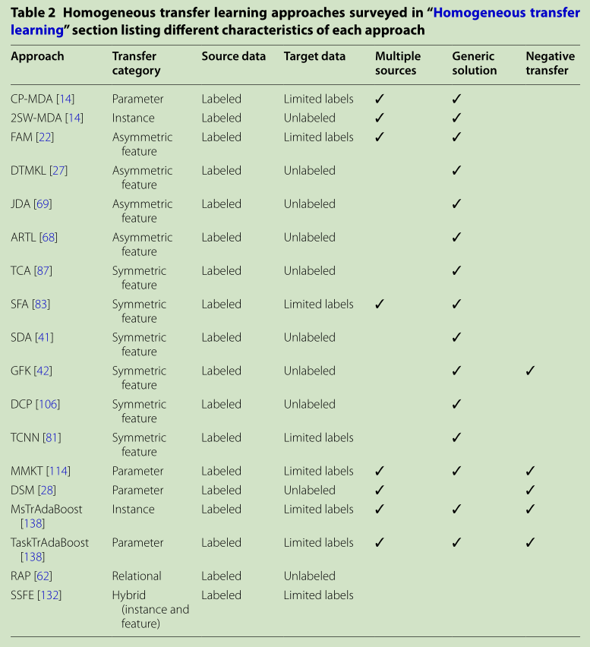

论文特点：

此论文相当于一篇文献综述，论文没有提出新的观点或者对某一理论进行论证，但是对迁移学习（transfer learning）这一领域的方法做了高度的整合和概括，介绍了其发展史，相当于一份提纲。